# ESOF 322 Homework 6

By Kyle Rust

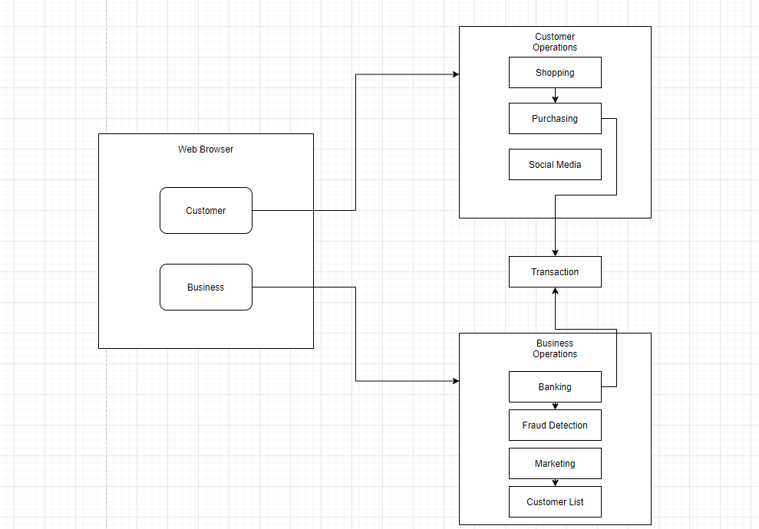

1. An E Commerce system is accessed through a web browser where the user provides login information. The two groups have access to two different sets of operations. If a customer account is accessed, they are redirected to a separate platform. From there they have the option to shop product, add products to their cart, and connect with the host businesses social media. If the business account is accessed a different set of operations are available. The business is able to do banking, which is protected by fraud detection, and use marketing applications to update their customer list. One operation these two classes of users share is the option to complete transactions. For customers this is where payments from Paypal or cards are processed. The business can pay vendors and accept payment from the customers who make purchases.
2. Diagram

   Description automatically generated
   1. The component is determined by the authentication component. Once a valid connection is established, login is information is provided, and from that information the correct experience is created.
3. Diagram

   Description automatically generated
   1. This is a UML class diagram for the Business to Customer Access. This design implements the strategy pattern. Instead of creating two separate classes for accessing dashboard. The methods for authenticating the connection and the displaying the dashboards are slightly different so those methods get overridden in the child class.